# Git Assignment-3

## Create a Git working directory, with the following branches:

### Develop

### F1

### f2

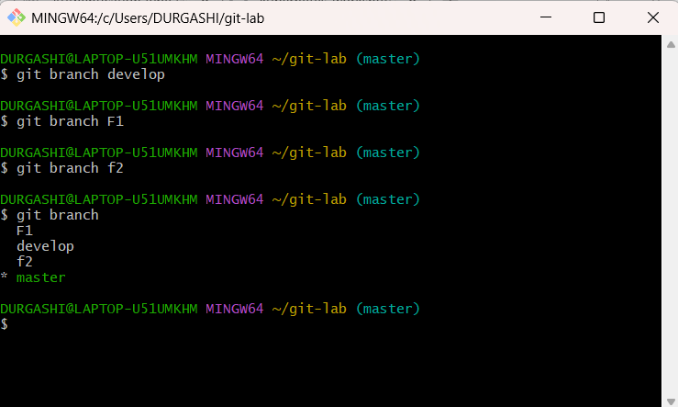

## In the master branch, commit main.txt file

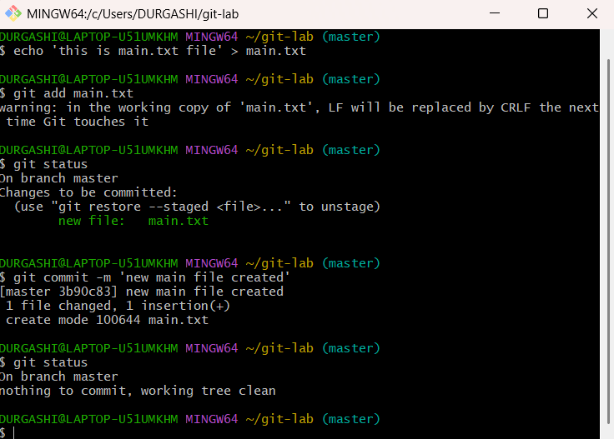

## Put develop.txt in develop branch, f1.txt and f2.txt in f1 and f2 respectively

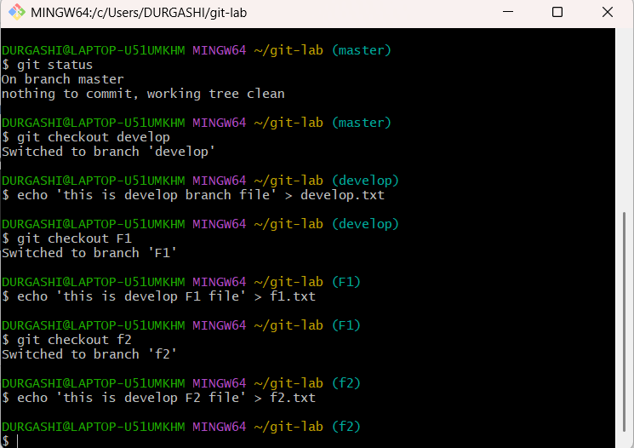

## Push all these branches to GitHub

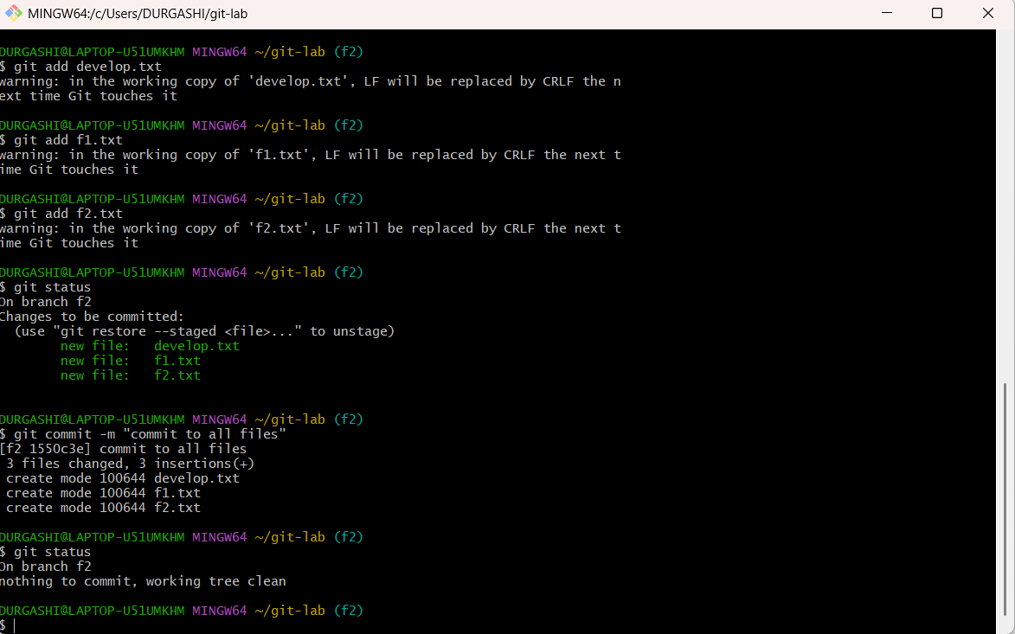

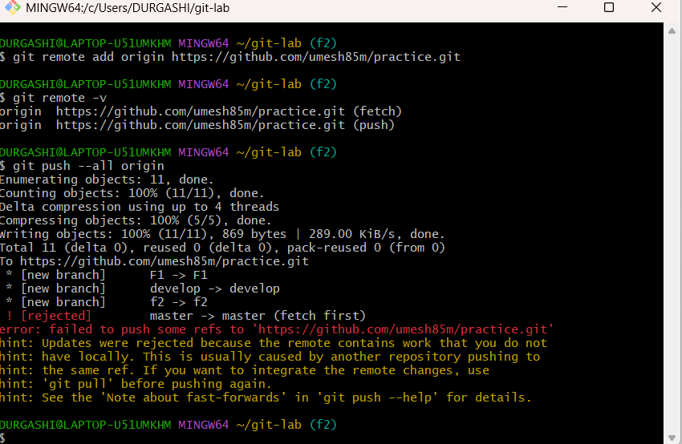

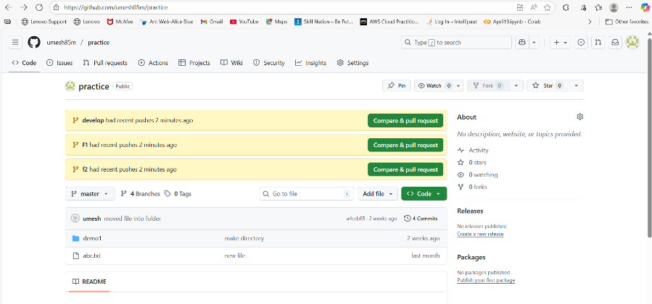

## On local delete f2 branch

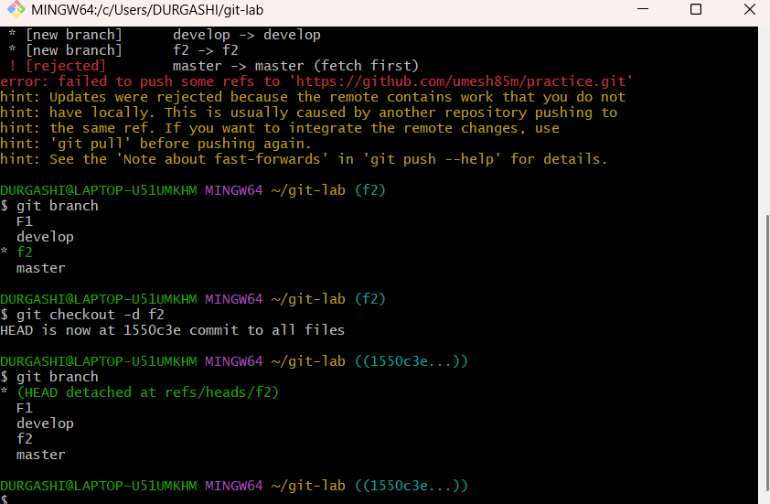

## Delete the same branch on GitHub as well

